**Nama : Muhammad Nazar Alfath**

**Stambuk : 13020170030**

**Kelas/Frequency : C1 /**

1. Activity_main.xml

<?xml version="1.0" encoding="utf-8"?>  
<LinearLayout xmlns:android="http://schemas.android.com/apk/res/android"  
 xmlns:app="http://schemas.android.com/apk/res-auto"  
 xmlns:tools="http://schemas.android.com/tools"  
 android:layout_width="match_parent"  
 android:layout_height="match_parent"  
 android:orientation="horizontal"  
 tools:context=".MainActivity">  
  
 <LinearLayout  
 android:layout_width="match_parent"  
 android:layout_height="match_parent"  
 android:background="@color/colorPrimaryDark"  
 android:layout_weight="1">  
 <LinearLayout  
 android:layout_width="match_parent"  
 android:layout_height="match_parent"  
 android:background="@color/colorAccent"  
 android:layout_margin="30dp"  
 android:orientation="vertical"  
 android:gravity="center">  
 <Button  
 android:layout_width="wrap_content"  
 android:layout_height="wrap_content"  
 android:text="Button 0">  
 </Button>  
 <Button  
 android:layout_width="wrap_content"  
 android:layout_height="wrap_content"  
 android:text="Button 0">  
 </Button>  
 <Button  
 android:layout_width="wrap_content"  
 android:layout_height="wrap_content"  
 android:text="Button 3">  
 </Button>  
 <Button  
 android:layout_width="wrap_content"  
 android:layout_height="wrap_content"  
 android:text="Button 0">  
 </Button>  
 </LinearLayout>  
 </LinearLayout>  
  
 <LinearLayout  
 android:layout_width="500dp"  
 android:layout_height="match_parent"  
 android:orientation="vertical"  
 android:layout_weight="1">  
 <LinearLayout  
 android:layout_width="match_parent"  
 android:layout_height="match_parent"  
 android:layout_weight="1">  
 <LinearLayout  
 android:layout_width="match_parent"  
 android:layout_height="100dp"  
 android:background="@color/colorPrimaryDark">  
 <LinearLayout  
 android:layout_width="match_parent"  
 android:layout_height="match_parent"  
 android:layout_margin="20dp"  
 android:background="@color/colorAccent"  
 android:gravity="center">  
 <Button  
 android:id="@+id/button"  
 android:layout_width="wrap_content"  
 android:layout_height="wrap_content"  
 android:text="Button 0">  
 </Button>  
 </LinearLayout>  
 </LinearLayout>  
 </LinearLayout>  
 <LinearLayout  
 android:layout_width="match_parent"  
 android:layout_height="match_parent"  
 android:layout_weight="1">  
 <LinearLayout  
 android:layout_width="match_parent"  
 android:layout_height="100dp"  
 android:layout_gravity="bottom"  
 android:background="@color/colorPrimaryDark">  
 <LinearLayout  
 android:layout_width="match_parent"  
 android:layout_height="match_parent"  
 android:layout_margin="20dp"  
 android:gravity="center"  
 android:background="@color/colorAccent">  
 <Button  
 android:layout_width="wrap_content"  
 android:layout_height="wrap_content"  
 android:text="Button 0">  
 </Button>  
 </LinearLayout>  
 </LinearLayout>  
 </LinearLayout>  
 </LinearLayout>  
  
 <LinearLayout  
 android:layout_width="match_parent"  
 android:layout_height="match_parent"  
 android:layout_weight="1"  
 android:background="@color/colorPrimaryDark">  
 <LinearLayout  
 android:layout_width="match_parent"  
 android:layout_height="match_parent"  
 android:layout_margin="30dp"  
 android:background="@color/colorAccent"  
 android:gravity="center"  
 android:orientation="vertical">  
 <Button  
 android:layout_width="wrap_content"  
 android:layout_height="wrap_content"  
 android:text="Button o">  
 </Button>  
 <Button  
 android:layout_width="wrap_content"  
 android:layout_height="wrap_content"  
 android:text="Button o">  
 </Button>  
 <Button  
 android:layout_width="wrap_content"  
 android:layout_height="wrap_content"  
 android:text="Button 3">  
 </Button>  
 <Button  
 android:layout_width="wrap_content"  
 android:layout_height="wrap_content"  
 android:text="Button o">  
 </Button>  
 </LinearLayout>  
 </LinearLayout>  
</LinearLayout>

1. MainActivity.java

package com.example.praktikummobile;  
  
import androidx.appcompat.app.AppCompatActivity;  
  
import android.content.Intent;  
import android.os.Bundle;  
import android.view.View;  
import android.widget.Button;  
  
public class MainActivity extends AppCompatActivity {  
  
 Button button;  
  
 @Override  
 protected void onCreate(Bundle savedInstanceState) {  
 super.onCreate(savedInstanceState);  
 setContentView(R.layout.*activity_main*);  
 button = findViewById(R.id.*button*);  
  
 button.setOnClickListener(new View.OnClickListener() {  
 @Override  
 public void onClick(View v) {  
 Intent intent = new Intent(MainActivity.this,Main3Activity.class);  
 startActivity(intent);  
 }  
 });  
 }  
}

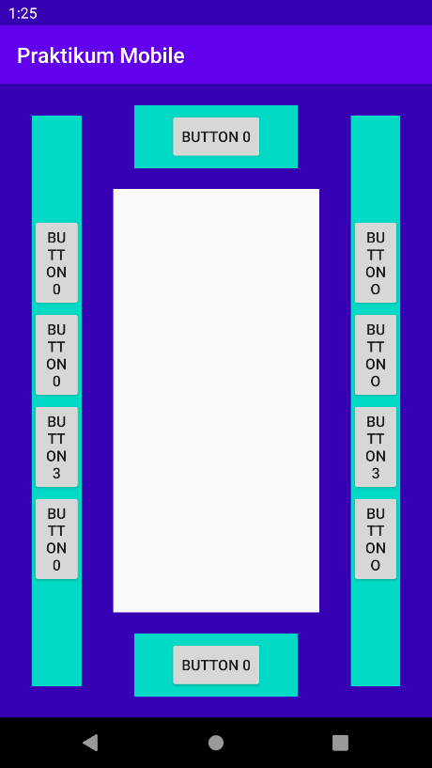

1. Activity_main3.xml
2. <?xml version="1.0" encoding="utf-8"?>  
   <LinearLayout xmlns:android="http://schemas.android.com/apk/res/android"  
    xmlns:app="http://schemas.android.com/apk/res-auto"  
    xmlns:tools="http://schemas.android.com/tools"  
    android:layout_width="match_parent"  
    android:layout_height="match_parent"  
    android:orientation="horizontal"  
    tools:context=".MainActivity">  
     
    <LinearLayout  
    android:layout_width="match_parent"  
    android:layout_height="match_parent"  
    android:background="@color/colorPrimaryDark"  
    android:layout_weight="1">  
    <LinearLayout  
    android:layout_width="match_parent"  
    android:layout_height="match_parent"  
    android:background="@color/colorAccent"  
    android:layout_margin="30dp"  
    android:orientation="vertical"  
    android:gravity="center">  
    <Button  
    android:layout_width="wrap_content"  
    android:layout_height="wrap_content"  
    android:text="Button 0">  
    </Button>  
    <Button  
    android:layout_width="wrap_content"  
    android:layout_height="wrap_content"  
    android:text="Button 0">  
    </Button>  
    <Button  
    android:layout_width="wrap_content"  
    android:layout_height="wrap_content"  
    android:text="Button 3">  
    </Button>  
    <Button  
    android:layout_width="wrap_content"  
    android:layout_height="wrap_content"  
    android:text="Button 0">  
    </Button>  
    </LinearLayout>  
    </LinearLayout>  
     
    <LinearLayout  
    android:layout_width="500dp"  
    android:layout_height="match_parent"  
    android:orientation="vertical"  
    android:layout_weight="1">  
    <LinearLayout  
    android:layout_width="match_parent"  
    android:layout_height="match_parent"  
    android:layout_weight="1">  
    <LinearLayout  
    android:layout_width="match_parent"  
    android:layout_height="100dp"  
    android:background="@color/colorPrimaryDark">  
    <LinearLayout  
    android:layout_width="match_parent"  
    android:layout_height="match_parent"  
    android:layout_margin="20dp"  
    android:background="@color/colorAccent"  
    android:gravity="center">  
    <Button  
    android:id="@+id/button"  
    android:layout_width="wrap_content"  
    android:layout_height="wrap_content"  
    android:text="Button 0">  
    </Button>  
    </LinearLayout>  
    </LinearLayout>  
    </LinearLayout>  
    <LinearLayout  
    android:layout_width="match_parent"  
    android:layout_height="match_parent"  
    android:layout_weight="1">  
    <LinearLayout  
    android:layout_width="match_parent"  
    android:layout_height="100dp"  
    android:layout_gravity="bottom"  
    android:background="@color/colorPrimaryDark">  
    <LinearLayout  
    android:layout_width="match_parent"  
    android:layout_height="match_parent"  
    android:layout_margin="20dp"  
    android:gravity="center"  
    android:background="@color/colorAccent">  
    <Button  
    android:layout_width="wrap_content"  
    android:layout_height="wrap_content"  
    android:text="Button 0">  
    </Button>  
    </LinearLayout>  
    </LinearLayout>  
    </LinearLayout>  
    </LinearLayout>  
     
    <LinearLayout  
    android:layout_width="match_parent"  
    android:layout_height="match_parent"  
    android:layout_weight="1"  
    android:background="@color/colorPrimaryDark">  
    <LinearLayout  
    android:layout_width="match_parent"  
    android:layout_height="match_parent"  
    android:layout_margin="30dp"  
    android:background="@color/colorAccent"  
    android:gravity="center"  
    android:orientation="vertical">  
    <Button  
    android:layout_width="wrap_content"  
    android:layout_height="wrap_content"  
    android:text="Button o">  
    </Button>  
    <Button  
    android:layout_width="wrap_content"  
    android:layout_height="wrap_content"  
    android:text="Button o">  
    </Button>  
    <Button  
    android:layout_width="wrap_content"  
    android:layout_height="wrap_content"  
    android:text="Button 3">  
    </Button>  
    <Button  
    android:layout_width="wrap_content"  
    android:layout_height="wrap_content"  
    android:text="Button o">  
    </Button>  
    </LinearLayout>  
    </LinearLayout>  
   </LinearLayout>
3. Main3Activity.java

package com.example.praktikummobile;  
  
import androidx.appcompat.app.AppCompatActivity;  
  
import android.content.Intent;  
import android.os.Bundle;  
import android.view.View;  
import android.widget.Button;  
  
public class Main3Activity extends AppCompatActivity {  
  
 @Override  
 protected void onCreate(Bundle savedInstanceState) {  
 super.onCreate(savedInstanceState);  
 setContentView(R.layout.*activity_main3*);  
 Button button = findViewById(R.id.*button*);  
  
 button.setOnClickListener(new View.OnClickListener() {  
 @Override  
 public void onClick(View v) {  
 Intent intent = new Intent(Main3Activity.this, Main2Activity.class);  
 startActivity(intent);  
 }  
 });  
 }  
}

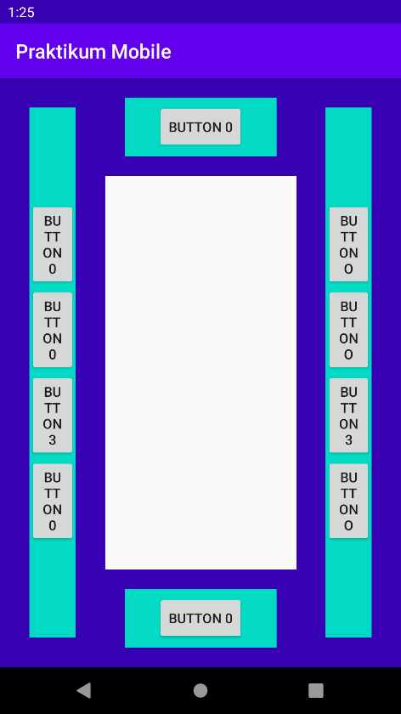

1. Activity_main2.xml

<?xml version="1.0" encoding="utf-8"?>  
<LinearLayout xmlns:android="http://schemas.android.com/apk/res/android"  
 xmlns:app="http://schemas.android.com/apk/res-auto"  
 xmlns:tools="http://schemas.android.com/tools"  
 android:layout_width="match_parent"  
 android:layout_height="match_parent"  
 tools:context=".Main2Activity">  
  
 <LinearLayout  
 android:layout_width="match_parent"  
 android:layout_height="match_parent"  
 android:layout_weight="1">  
 <LinearLayout  
 android:layout_width="500dp"  
 android:layout_height="match_parent"  
 android:orientation="vertical"  
 android:layout_weight="1">  
 <LinearLayout  
 android:layout_width="match_parent"  
 android:layout_height="match_parent"  
 android:layout_weight="1">  
 <LinearLayout  
 android:layout_width="match_parent"  
 android:layout_height="100dp"  
 android:background="@color/colorPrimaryDark">  
 <LinearLayout  
 android:layout_width="match_parent"  
 android:layout_height="match_parent"  
 android:layout_margin="20dp"  
 android:background="@color/colorAccent"  
 android:gravity="center">  
 <Button  
 android:layout_width="wrap_content"  
 android:layout_height="wrap_content"  
 android:text="Button 0">  
 </Button>  
 </LinearLayout>  
 </LinearLayout>  
 </LinearLayout>  
 <LinearLayout  
 android:layout_width="match_parent"  
 android:layout_height="match_parent"  
 android:layout_weight="1">  
 <LinearLayout  
 android:layout_width="match_parent"  
 android:layout_height="100dp"  
 android:layout_gravity="center"  
 android:background="@color/colorPrimaryDark">  
 <LinearLayout  
 android:layout_width="match_parent"  
 android:layout_height="match_parent"  
 android:layout_margin="20dp"  
 android:gravity="center"  
 android:background="@color/colorAccent">  
 <Button  
 android:id="@+id/button"  
 android:layout_width="wrap_content"  
 android:layout_height="wrap_content"  
 android:text="Button 0">  
 </Button>  
 </LinearLayout>  
 </LinearLayout>  
 </LinearLayout>  
 <LinearLayout  
 android:layout_width="match_parent"  
 android:layout_height="match_parent"  
 android:layout_weight="1">  
 <LinearLayout  
 android:layout_width="match_parent"  
 android:layout_height="100dp"  
 android:layout_gravity="bottom"  
 android:background="@color/colorPrimaryDark">  
 <LinearLayout  
 android:layout_width="match_parent"  
 android:layout_height="match_parent"  
 android:layout_margin="20dp"  
 android:gravity="center"  
 android:background="@color/colorAccent">  
 <Button  
 android:layout_width="wrap_content"  
 android:layout_height="wrap_content"  
 android:text="Button 0">  
 </Button>  
 </LinearLayout>  
 </LinearLayout>  
 </LinearLayout>  
 </LinearLayout>  
 </LinearLayout>  
  
 <LinearLayout  
 android:layout_width="match_parent"  
 android:layout_height="match_parent"  
 android:background="@color/colorPrimaryDark"  
 android:layout_weight="2">  
 <LinearLayout  
 android:layout_width="match_parent"  
 android:layout_height="match_parent"  
 android:background="@color/colorAccent"  
 android:layout_margin="20dp"  
 android:gravity="center"  
 android:orientation="vertical">  
 <Button  
 android:layout_width="wrap_content"  
 android:layout_height="wrap_content"  
 android:text="Button 0">  
 </Button>  
 <Button  
 android:layout_width="wrap_content"  
 android:layout_height="wrap_content"  
 android:text="Button 0">  
 </Button>  
 <Button  
 android:layout_width="wrap_content"  
 android:layout_height="wrap_content"  
 android:text="Button 0">  
 </Button>  
 <Button  
 android:layout_width="wrap_content"  
 android:layout_height="wrap_content"  
 android:text="Button 0">  
 </Button>  
 </LinearLayout>  
 </LinearLayout>  
</LinearLayout>

1. Main2Activity.java

package com.example.praktikummobile;  
  
import androidx.appcompat.app.AppCompatActivity;  
  
import android.content.Intent;  
import android.os.Bundle;  
import android.view.View;  
import android.widget.Button;  
  
public class Main2Activity extends AppCompatActivity {  
  
 @Override  
 protected void onCreate(Bundle savedInstanceState) {  
 super.onCreate(savedInstanceState);  
 setContentView(R.layout.*activity_main2*);  
 Button button = findViewById(R.id.*button*);  
 button.setOnClickListener(new View.OnClickListener() {  
 @Override  
 public void onClick(View v) {  
 Intent intent = new Intent(Main2Activity.this, Main4Activity.class);  
 startActivity(intent);  
 }  
 });  
 }  
}

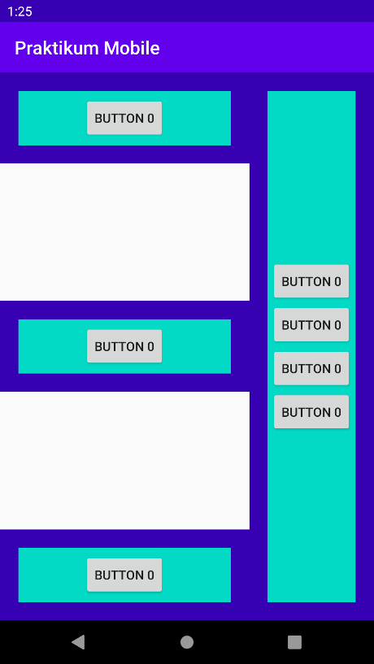

1. Activity_main4.xml

<?xml version="1.0" encoding="utf-8"?>  
<LinearLayout xmlns:android="http://schemas.android.com/apk/res/android"  
 xmlns:app="http://schemas.android.com/apk/res-auto"  
 xmlns:tools="http://schemas.android.com/tools"  
 android:layout_width="match_parent"  
 android:layout_height="match_parent"  
 android:orientation="horizontal"  
 tools:context=".MainActivity">  
  
 <LinearLayout  
 android:layout_width="match_parent"  
 android:layout_height="match_parent"  
 android:background="@color/colorPrimaryDark"  
 android:layout_weight="1">  
 <LinearLayout  
 android:layout_width="match_parent"  
 android:layout_height="match_parent"  
 android:background="@color/colorAccent"  
 android:layout_margin="30dp"  
 android:orientation="vertical"  
 android:gravity="center">  
 <Button  
 android:layout_width="wrap_content"  
 android:layout_height="wrap_content"  
 android:text="Button 0">  
 </Button>  
 <Button  
 android:layout_width="wrap_content"  
 android:layout_height="wrap_content"  
 android:text="Button 0">  
 </Button>  
 <Button  
 android:layout_width="wrap_content"  
 android:layout_height="wrap_content"  
 android:text="Button 3">  
 </Button>  
 <Button  
 android:layout_width="wrap_content"  
 android:layout_height="wrap_content"  
 android:text="Button 0">  
 </Button>  
 </LinearLayout>  
 </LinearLayout>  
  
 <LinearLayout  
 android:layout_width="500dp"  
 android:layout_height="match_parent"  
 android:orientation="vertical"  
 android:layout_weight="1">  
 <LinearLayout  
 android:layout_width="match_parent"  
 android:layout_height="match_parent"  
 android:layout_weight="1">  
 <LinearLayout  
 android:layout_width="match_parent"  
 android:layout_height="100dp"  
 android:background="@color/colorPrimaryDark">  
 <LinearLayout  
 android:layout_width="match_parent"  
 android:layout_height="match_parent"  
 android:layout_margin="20dp"  
 android:background="@color/colorAccent"  
 android:gravity="center">  
 <Button  
 android:id="@+id/button"  
 android:layout_width="wrap_content"  
 android:layout_height="wrap_content"  
 android:text="Button 0">  
 </Button>  
 </LinearLayout>  
 </LinearLayout>  
 </LinearLayout>  
 <LinearLayout  
 android:layout_width="match_parent"  
 android:layout_height="match_parent"  
 android:layout_weight="1">  
 <LinearLayout  
 android:layout_width="match_parent"  
 android:layout_height="100dp"  
 android:layout_gravity="bottom"  
 android:background="@color/colorPrimaryDark">  
 <LinearLayout  
 android:layout_width="match_parent"  
 android:layout_height="match_parent"  
 android:layout_margin="20dp"  
 android:gravity="center"  
 android:background="@color/colorAccent">  
 <Button  
 android:layout_width="wrap_content"  
 android:layout_height="wrap_content"  
 android:text="Button 0">  
 </Button>  
 </LinearLayout>  
 </LinearLayout>  
 </LinearLayout>  
 </LinearLayout>  
  
 <LinearLayout  
 android:layout_width="match_parent"  
 android:layout_height="match_parent"  
 android:layout_weight="1"  
 android:background="@color/colorPrimaryDark">  
 <LinearLayout  
 android:layout_width="match_parent"  
 android:layout_height="match_parent"  
 android:layout_margin="30dp"  
 android:background="@color/colorAccent"  
 android:gravity="center"  
 android:orientation="vertical">  
 <Button  
 android:layout_width="wrap_content"  
 android:layout_height="wrap_content"  
 android:text="Button o">  
 </Button>  
 <Button  
 android:layout_width="wrap_content"  
 android:layout_height="wrap_content"  
 android:text="Button o">  
 </Button>  
 <Button  
 android:layout_width="wrap_content"  
 android:layout_height="wrap_content"  
 android:text="Button 3">  
 </Button>  
 <Button  
 android:layout_width="wrap_content"  
 android:layout_height="wrap_content"  
 android:text="Button o">  
 </Button>  
 </LinearLayout>  
 </LinearLayout>  
</LinearLayout>

1. Main4Activity.java

package com.example.praktikummobile;  
  
import androidx.appcompat.app.AppCompatActivity;  
  
import android.content.Intent;  
import android.os.Bundle;  
import android.view.View;  
import android.widget.Button;  
  
public class Main4Activity extends AppCompatActivity {  
  
 @Override  
 protected void onCreate(Bundle savedInstanceState) {  
 super.onCreate(savedInstanceState);  
 setContentView(R.layout.*activity_main4*);  
 Button button = findViewById(R.id.*button*);  
 }  
}

